QSRAC: A Quantum-Safe, Risk-Adaptive Stateful Access Control Framework with Cryptographic Continuity and Atomic Enforcement
I. Abstract
This paper presents QSRAC, a quantum-safe, risk-adaptive access control framework that integrates post-quantum cryptography, machine learning-based risk scoring, and stateful authorization. The system addresses key limitations of traditional models, including replay attacks, session tampering, and TOCTOU vulnerabilities.
QSRAC enforces cryptographic state continuity using a hash-chain-based envelope and ensures atomic state transitions via a Redis Lua mechanism. Risk is dynamically computed using an Isolation Forest model, while trust evolves through an exponential decay function.
A secure MFA-based state repair mechanism enables trust recovery without bypassing the authorization state machine. Experimental results show effective separation of normal and attack behavior with low false positives and no false negatives.

II. Keywords
Post-Quantum Cryptography, Risk-Adaptive Access Control, Zero Trust, Isolation Forest, Stateful Authorization, Replay Protection, TOCTOU, Trust Decay, MFA

III. Introduction
A. Background
Traditional access control models such as RBAC and ABAC rely on static policies and assume trust after authentication. However, modern distributed and zero-trust environments require continuous verification due to dynamic threats. Additionally, classical cryptographic schemes are vulnerable to future quantum attacks.
B. Motivation
Existing systems suffer from:
Lack of runtime risk awareness
No state continuity across requests
Exposure to replay and TOCTOU vulnerabilities
Although RAdAC and PQC exist, they are typically isolated solutions and not integrated into a unified authorization framework.
C. Problem Statement
Current access control systems fail to provide continuous, stateful, and cryptographically verifiable authorization, leading to:
Replay attacks due to stateless sessions
Inconsistent decisions from race conditions
Weak binding between identity, context, and authorization state
D. Objectives
The objectives of this work are:
Design a quantum-safe access control framework using PQC
Integrate ML-based runtime risk scoring
Enforce state continuity using hash chaining
Eliminate TOCTOU vulnerabilities via atomic state transitions
Implement adaptive trust modeling with secure recovery (MFA)
E. Contributions
This paper makes the following contributions:
A stateful authorization model binding identity, risk, trust, and context per request
A hash-chain-based mechanism ensuring replay protection and integrity
Integration of Isolation Forest for real-time risk evaluation
A Redis Lua-based atomic enforcement layer preventing race conditions
A trust decay and MFA-based state repair mechanism without bypassing the system

IV. Literature Review
A. Post-Quantum Cryptography in Access Control
Post-Quantum Cryptography (PQC) addresses threats from quantum computing, particularly against RSA and ECC. Lattice-based schemes such as ML-KEM (Kyber) and ML-DSA (Dilithium) provide strong security with practical performance. However, existing work mainly focuses on secure communication (e.g., TLS) and not runtime authorization.
Gap: PQC is not integrated into per-request, stateful access control systems.

B. Risk-Adaptive Access Control (RAdAC)
RAdAC extends RBAC/ABAC by incorporating contextual risk into decisions. It is widely used in Zero Trust Architecture for continuous evaluation. While flexible, most implementations rely on policy logic without cryptographic guarantees and lack state continuity.
Gap: No cryptographic binding between sequential authorization decisions.
C. Machine Learning for Security
Machine learning techniques, especially Isolation Forest, are effective for anomaly detection due to efficiency and scalability. They enable real-time risk scoring based on behavioral patterns. However, ML outputs are typically used as auxiliary signals, not tightly integrated into secure enforcement mechanisms.
Gap: Lack of binding between ML-based risk and authorization state evolution.

D. Replay Prevention and Stateful Security
Replay protection techniques include nonces and hash chains, which ensure message freshness and integrity. While effective, they are often limited to protocol-level security and not applied to authorization workflows.
Gap: Absence of unified models combining replay protection with authorization logic.

E. TOCTOU and Atomic Enforcement
TOCTOU vulnerabilities arise when validation and execution are separated, leading to race conditions. Atomic mechanisms like Redis Lua scripting ensure consistency by combining validation and update in a single step. However, their use in access control systems is limited.
Gap: Atomic enforcement is not widely applied to authorization state transitions.

F. Trust Modeling and MFA
Modern systems treat trust as dynamic, often using decay models based on behavior and context. Adaptive MFA enhances security by triggering additional verification under risk. However, MFA is usually limited to authentication and not used for state repair.
Gap: Lack of integrated trust lifecycle combining decay and secure recovery.

G. Summary of Gaps
Across existing research:
PQC is not used in runtime authorization
RAdAC lacks cryptographic enforcement
ML risk is not bound to secure state
Replay protection is fragmented
TOCTOU mitigation is not integrated
Trust recovery mechanisms are incomplete

V. Proposed System / Methodology
A. System Overview
QSRAC is a stateful, risk-adaptive access control framework combining PQC, ML-based risk scoring, and cryptographic state continuity. It operates in two phases:
Slow Path: Session initialization using PQC
Fast Path: Per-request authorization with minimal latency

B. System Architecture
The system consists of:
Client Wrapper: Maintains sequence and envelope
Middleware: Verifies token, extracts context, computes risk/trust
ML Module: Generates risk using Isolation Forest
Envelope Engine: Creates cryptographic state per request
Redis Lua Engine: Ensures atomic state updates
Policy Engine: Maps risk and trust to decisions

C. Cryptographic Design
1) Session Establishment (Slow Path)
PQC-based key exchange (ML-KEM / Kyber)
PQC signatures (ML-DSA / Dilithium)
Outputs: session key, signed token, initial state
2) Stateful Authorization (Fast Path)
Each request generates a new cryptographic envelope containing:
Context hash
Previous hash
Risk and trust
Sequence number
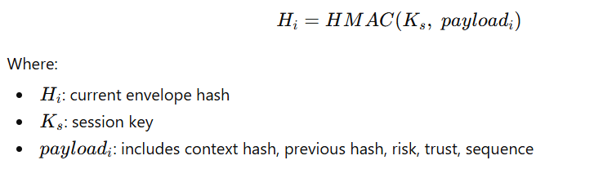
This ensures:
Forward integrity
Tamper detection
Replay resistance

D. Context and Risk Computation
Context features include:
Request rate, failed attempts
Geo risk, device trust
VPN/TOR usage, sensitivity
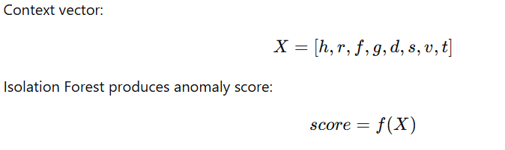
These are processed by the ML model to classify risk into:
Low, Medium, High, Critical

E. Trust Model
Trust evolves dynamically using exponential decay:
Decreases with higher risk and time
Bounded between 0 and 1
Computed per request
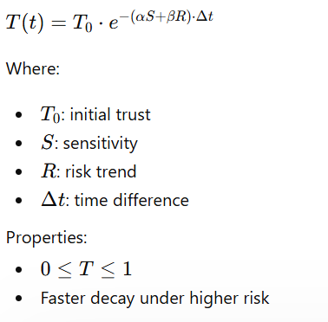

F. Stateful Authorization Flow
For each request:
Verify token signature
Extract context
Validate sequence + hash-chain
Compute risk (ML) and trust (decay)
Generate new envelope
Execute atomic Redis validation + update
Apply policy decision
Return updated state

G. Atomic State Enforcement
Redis Lua ensures:
Strict sequence increment
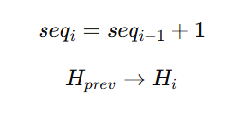
Hash-chain continuity
Atomic validation + update
This eliminates:
Replay attacks
TOCTOU vulnerabilities
guarantees single consistent state

H. Policy Decision Model
Decisions depend on risk and trust:
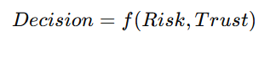
Low + High → Allow
Medium + Low → Step-Up
High/Critical + Low → Block
RBAC/ABAC act as pre-filters, while final decisions are dynamic.

I. MFA-Based State Repair
When trust is low:
MFA challenge is issued
Verified using session key (HMAC)
On success:
Trust increases
Sequence advances
Hash-chain remains intact
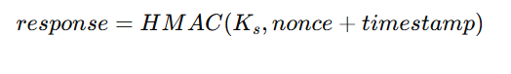
Ensures:
No bypass of state machine
Secure recovery without reset

J. Key Novelty
Cryptographically evolving authorization state
ML risk bound to secure state transitions
Hash-chain enforced continuity
Atomic TOCTOU elimination
MFA as state repair mechanism

VI. Implementation / Experimental Setup
A. Tools and Technologies
The system is implemented using a modular Python stack:
Backend: FastAPI
Cryptography: PQC (Kyber KEM, Dilithium signatures) with fallback
Machine Learning: Isolation Forest (scikit-learn)
State Store: Redis with Lua scripting
Environment Config: Secure .env loading

B. System Components Implementation
Client Wrapper:
Handles key exchange and session initialization
Maintains sequence (seq) and envelope
Middleware:
Verifies token signature
Extracts context
Computes risk and trust
Enforces ABAC and state validation
Envelope Engine:
Generates hash-bound state per request
Redis Lua Engine:
Performs atomic validation (seq + hash-chain)
Updates trust and session state
Policy Engine:
Maps risk + trust → decision (Allow / Deny / Step-Up)

C. Dataset Description
Synthetic dataset:
Normal samples: 800
Low request rate, high device trust
Attack samples: 200
High request rate, low trust, VPN/TOR usage
Features:
request rate, failed attempts
geo risk score
device trust score
sensitivity level

D. Model Training
Algorithm: Isolation Forest
Parameters:
n_estimators = 100
contamination = 0.05
Preprocessing: StandardScaler normalization
Model is trained and saved using joblib.

E. Threshold Calibration
Risk levels derived from score distribution:
Low ≈ -0.4449
Medium ≈ -0.5381
High ≈ -0.6313
Used at runtime for classification.

F. Experimental Environment
Localhost deployment
FastAPI server
Python client wrapper
Redis single-node instance

G. Evaluation Setup
Test scenarios:
Normal traffic
High-risk anomalies
Replay attacks
Sequence tampering
Envelope tampering
Concurrent requests
MFA-triggered recovery

H. Logging and Monitoring
Asynchronous audit logging
Captures:
session ID
decision
risk
trust
Ensures minimal impact on request latency.

VII. Results and Discussion
A. Risk Scoring Performance
The Isolation Forest model shows clear separation between normal and attack samples.
Normal traffic → predominantly Low/Medium risk
Attack traffic → predominantly High/Critical risk
This indicates effective anomaly detection and reliable risk classification.

B. Detection Metrics
Experimental results show:
False Positive Rate (FPR): ≈ 6–7%
False Negative Rate (FNR): 0%
This demonstrates:
Low misclassification of legitimate requests
Strong detection of adversarial behavior

C. Security Validation
The system successfully enforces:
Replay Protection:
Sequence validation prevents reuse of requests
Hash Integrity:
Hash-chain ensures tamper detection
Token Authenticity:
Cryptographic signature verification ensures integrity
TOCTOU Elimination:
Atomic Redis Lua execution removes race conditions

D. Stateful Consistency
Multi-request sessions maintain consistent state progression
Concurrent requests do not cause corruption due to atomic enforcement
Desynchronized or invalid states are safely rejected

E. Adaptive Behavior
Risk-aware decisions: dynamically adjust per request
Trust decay: reduces trust under risky behavior
Policy decisions: correctly map (Allow / Step-Up / Deny / Block)

F. Attack Handling
System behavior under adversarial scenarios:
Replay attacks → blocked
Envelope tampering → rejected
Invalid tokens → denied
Missing headers → rejected
Redis failures → safe fail (503)

G. MFA Evaluation
MFA challenge-response is nonce-based and replay-safe
Requires valid session and cryptographic verification
Ensures no bypass of state machine
Successfully restores trust while maintaining sequence continuity

H. Discussion
The results confirm that QSRAC:
Provides strong security guarantees
Maintains stateful consistency under concurrency
Integrates ML, cryptography, and system design effectively
The combination of hash-chain continuity + atomic enforcement + adaptive trust ensures both security and scalability in zero-trust environments.

VIII. Conclusion and Future Work
A. Conclusion
This paper presented QSRAC, a quantum-safe, risk-adaptive, and stateful access control framework that integrates post-quantum cryptography, machine learning-based risk evaluation, and cryptographic state continuity.
The system successfully addresses key limitations of traditional models by:
Enforcing replay-safe, hash-chain-based state evolution
Eliminating TOCTOU vulnerabilities through atomic Redis enforcement
Integrating ML-driven risk scoring into authorization decisions
Modeling dynamic trust with decay and recovery mechanisms
Experimental results demonstrate that QSRAC achieves high detection accuracy, strong consistency, and robust security guarantees, making it suitable for zero-trust and distributed environments.

B. Future Work
Future enhancements can include:
Deployment in distributed/multi-node environments for scalability evaluation
Integration with real-world datasets for improved ML robustness
Exploration of explainable AI (XAI) for better interpretability of risk decisions
Optimization of PQC performance for reduced latency and overhead

